**DTR PROD MOUNT ISSUE**

If there is any alert mail saying ‘p1l00590g:Colo1_LX_MOUNT-/MNT/DOCKER_Critical:Used_percent was 80.10 %”

We have to perform below steps to resolve mount issue:

***NOTE: We have to perform below steps only after checking with Sasikanth, Kapil and Naveen***

* Go to /mnt/docker/docker/containers

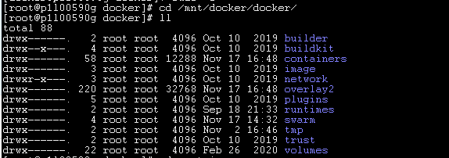

* Check the size of containers using du -sch * :

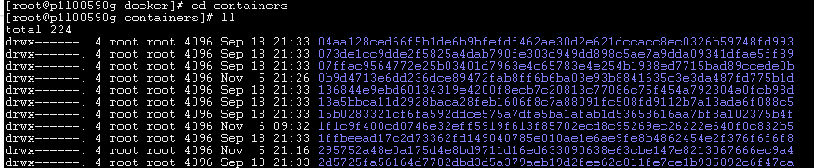

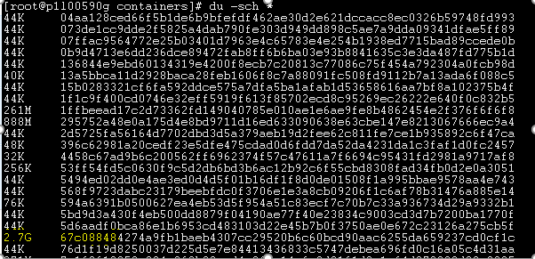

* Check container with highest size using docker ps and grep that container, which image and command it is using. Please proceed with the clean-up if it is only DTR registry, rethink and nginx. If there is any other container occupying large space please discuss with team on that.



* CD into that container:

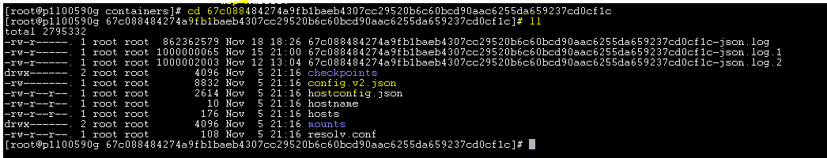

* We have to empty .json file using   
  *echo “”>filename-json.log*

Note: Please take a peer review from anyone experienced with this activity before running this command as it will clear up the files content